**ECE 411 Product Design Specification**

**Executive Summary/Concept of Operations**

Majority of the fans used today are controlled manually. These fans that controlled by hands has some obvious disadvantages. In summers, we often use fans to cool down. However, we often feel cold after we open fans for a long time because the room temperature is decreased. At this moment, we need stand up, go to switch off fans, and turn the gears to lower speed of fans. This a series of the process make people inconvenient. Hence, we hereby introduce an efficient temperature-controlled fan which turns on and off according to the room temperature automatically. This circuit uses an LM35 temperature sensor to measure the room temperature. When the measured temperature exceeds the threshold value, the fan will turn on at a certain speed. This product can prevent energy waste and help to monitor the environment.

**Brief Market Analysis**

Our ideal customers are small pet owners, in places like Portland, where the typical home doesn’t have air conditioning. This product would be ideal for pet owners who want to be able to cool their pets in a cost-effective manner, particularly in situations when the pet owner leaves and returns in the coolest parts of the day. Our product would automatically turn on when the temperature reached a certain threshold and provide the pet with some comfort until the temperature in the cage dropped below that set threshold. Additionally, this product has the potential, ideally, to be further improved on for use as a replacement controller for older freezers.

Market need: General trend toward sustainable lifestyle and energy saving provide a good selling opportunity.

Competition: While there is plenty of pet fan there, none of them are automated. Based on the preliminary research, we found that there is minimal competition for our product. The lack of an automated fan forces pet owners to settle for an inefficient system and throw more money away on batteries and replacement devices. This means that there is a niche spot in the pet care arena perfect for our product.

The product cost would be around $18 for retail price, because of pet owners willing to provide an automatic cooling system for their pet in a cage. The design is possible to scale for use for a bigger fan by modifying the USB power input versus into a traditional power cord and supply.

**Requirements**

* **Must**
  + Have a sensor to measure the surrounding area temperature.
  + Have a fan that will turn on when the temperature increases beyond a defined setpoint and shuts off automatically when the temperature drops below that defined setpoint.
  + Must have a power switch.
* **Should**
  + Have an LCD screen to display the room temperature and the threshold value.
  + Have user interface, to allow for user-defined thresholds.
  + Work on battery or USB power
* **May**
  + Add a LED to show functionality
  + Demonstrate the value of saving energy

**System Architecture**

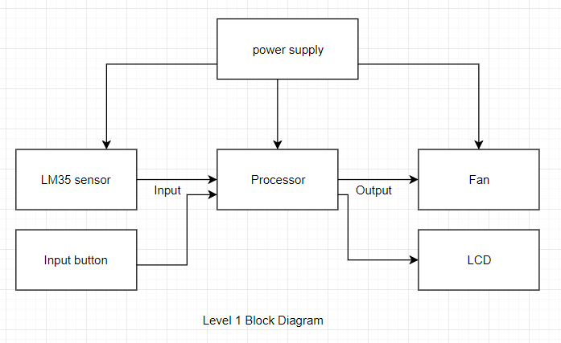

*Figure 1: Level 1 block diagram of the proposed design*

**Design Specification**

* Sensor: LM35 temperature sensor
* Processor: Atmega32U4
* The system controls a fan
* Powered by USB and 9V Battery
* Developed using Arduino
* PCBA in a housing containing a fan